CoViD X-Ray Image Classification using Deep Learning

Robert Wilcox, Sr.
U. of Illinois - Champaign
Monee, IL
rwilcox3@illinois.edu

Emil Varghese
U. of Illinois - Champaign
Burbank, CA
emilv2@illinois.edu

Charles Beyer
U. of Illinois - Champaign
Glenview, IL
ccbeyer2@illinois.edu

Tyler Bybee
U. of Illinois - Champaign
Des Moines, IA
tbybee2@illinois.edu

INTRODUCTION / MOTIVATION

As of March, 2021, there have been over 100 million cases of the novel coronavirus disease 2019 (COVID-19) around the world, and almost 3 million deaths [1]. Due to the recency of the disease, there are relatively fewer x-ray images related to the disease compared to non-COVID-19 related x-ray images, which makes developing effective deep learning models difficult [2].

There have been developments in ensemble neural networks, specifically, FLANNEL (Focal Loss bAsed Neural Network EnsembLe) to classify x-rays of COVID-related pneumonia, and we hope to increase the accuracy of a FLANNEL model by introducing preprocessing in the form of image augmentation and by attempting to improve the accuracy of the worst performing basis model of the ensemble. Traditional data augmentation methods have demonstrated promise for increasing the accuracy of Convolutional Neural Networks and we hope that by increasing the accuracy of a basis model of the ensemble, the overall accuracy would increase [4]. This would allow for faster and more accurate diagnosis of patients suspected of having COVID-19, to assess appropriate treatment options faster.

LITERATURE SURVEY

Our team searched through 6 reference papers to learn more about state of the art in CoViD-19 classification of images, focuses mostly on X-ray imagery with one paper that used CT for a comparison.

The first paper is the FLANNEL paper produced by Prof. Sun and will be the basis of our project. FLANNEL uses an ensemble technique combining 5 state-of-the-art convolutional neural network (CNN) classifiers as based models [2]. Data used in the paper is available publicly as well as the basis of the code for the project. The model, compared with the baseline shows a higher macro-F1 score with 6% relative increase on the COVID-19 identification task [2].

The second paper, entitled “COVID-19 detection from scarce chest x-ray image data using few-shot deep learning approach” [5] uses a few-shot approach which is well-suited to scarcity in data,
which still seems to be the case for our problem domain, to the author’s best knowledge. Like the FLANNEL paper, the approach employs transfer learning, but the use of unsupervised learning and few-shot seem to be a potentially novel aspect of their approach. The work produced a 96.4% accuracy over the 83% of the baseline. The work also classifies normal, covid, and pneumonia in the models. The few-shot approach employs a Siamese network, which there are reference implementations for, though not included in pytorch. Given the capabilities of few-shot learning that are exhibited by GPT-3, the authors feel that this could be a potentially useful avenue to integrate into the FLANNEL approach.

The third paper reviewed is the COVD-Net paper which was used in the FLANNEL paper to compare performance and is also referenced by a number of other papers in this area of research. The models achieved a 93.3% accuracy and employs CNNs in what the authors titled PEPIX to represent their Projection-Expansion-Projection-Expansion architecture [6]. In order to add explain ability as well as audit the model, the authors used GSInquire. This tool highlights areas on the image that the model believes are features. This was then evaluated by radiologists to verify that the model was using valid features for classification.

The fourth paper is the AICOVID paper that was also used for comparison within the FLANNEL paper [7]. In this approach, deep learning is used in the detection of COVID, normal, and pneumonia data. What is unique about this paper is that CT images were used instead of X-rays. The paper is a good resource for us to see another approach, though CT images are not as readily available to the authors best knowledge and so would not be a source for a potential solution. This work had very good performance, reporting a 96% accuracy. However, in comparison of the F1 scores done in the FLANNEL paper [2] and considering the higher quality of CT imagery, the authors find the results surprising.

The fifth paper is entitled, “Deep-COVID: Predicting COVID-19 from chest X-ray images using deep transfer learning” [8]. In this paper, the authors use ResNet18, ResNet50, SqueezeNet, and DenseNet-161 models to do transfer learning on covid-19 classification. The authors used a fine tuning technique on these existing models that is similar to the approach in FLANNEL. For a sensitivity rate of 98%, these models achieved a specificity rate of around 90% on average [8]. The authors also applied a heatmap solution similar to the one used in FLANNEL. In reviewing the heatmap against the radiologist’s analysis, it appears that although the classification was correct, the features used in making that decision were off at times.

The sixth paper, entitled “Classification of COVID-19 chest X-rays with deep learning: new models or fine tuning” [9], is very similar in it’s approach as the previous paper. This time the author compared the performance of AlexNet, GoogleNet, and SqueezeNet. The approach utilized CNN in their models. The author’s approach was to gather 6 separate datasets, 2 of which used 3 class classification (normal, pneumonia, Covid) and focused again on adjusting the parameters of the pre-trained models. Accuracy measured on the range of 95.9 – 99.2%. The related works section in the paper is very good and served for additional information for the team.

DATA

The following data sets will be utilized for this project.

COVID Chest X-ray Dataset. This is a public dataset containing the chest X-rays of patients who are positive or suspected of COVID-19 or other viral and bacterial pneumonias. This data is collected from public sources. This data set has 542 images from 262 people. The data set is available at
https://github.com/ieee8023/covid-chestxray-dataset

COVID-19 X-ray Dataset This dataset contains X-rays of patients with COVID-19, pneumonia and no disease. This dataset is combination of the data from multiple sources. This contains 127 images collected from COVID dataset and Normal and pneumonia images are from ChestX-ray8 database. This data set is available at
https://github.com/muhammedtalo/COVID-19
If required, we might also make use of the following Kaggle dataset
https://www.kaggle.com/paultimothymooney/chest-xray-pneumonia
As part of the project, we plan to combine the COVID-19 datasets to setup the experimental data universe. Since COVID X-ray images are rare, we might add images from the Kaggle dataset depending on the initial performance of the model.
Image resizing/scaling will be done as part of preprocessing so that the data will be consistent across. This is also required so that any symbols/markings within the X-rays can be avoided.

Approach

One approach we will use to attempt the improvement of the FLANNEL model is to use traditional forms of image augmentation to preprocess the images prior to the model being trained with them. Due to the small number of images, FLANNEL utilizes transfer learning/pretrained models for its basis models, which are then fine tuned on the x-ray images for the COVID-19 classification task. Due to the small dataset, overfitting is a risk, so image manipulation can be used to train the model to generalize better. Additionally, only image resizing, random flip, noise, and normalization are used in the FLANNEL model, and there are various other ways the images can be augmented, which could improve accuracy [3][4]. We will measure performance by F1-score.
We will also attempt to improve the accuracy of the FLANNEL model by replacing the Vgg-19_bn model with a different pretrained image classification model, as the Vgg model is the model with the lowest accuracy of the five basis models used in FLANNEL. There are various CNNs we will evaluate for this, but pretrained weights (parameters) will be used in the same method as FLANNEL, where the pretrained model first has its final layer replaced with 4 outputs pertaining to the x-ray labels, at which point it is trained with all of the weights frozen besides the output layer. Then, following the initial training, all weights will be unfrozen so the model can be fine-tuned. This approach will also measure performance by F1-Score.

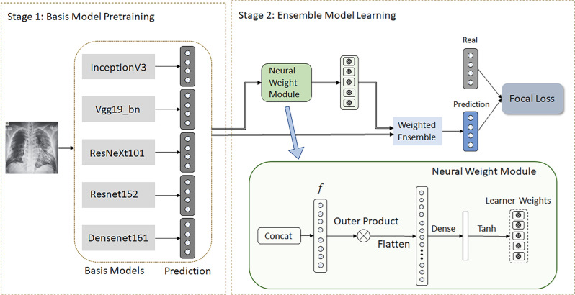
Figure. 1: FLANNEL Reference Architecture [2]

Experimental Setup

The following software will be used for this project.
Software – Python, PyTorch, Torchvision. Use Google Colabs (https://colab.research.google.com) for collaboration.
Hardware – For training, use one of the accelerator optimized virtual machines in Google Cloud/AWS. Machine considerations in Google Cloud - A2 VMs are preconfigured with a set number of NVIDIA A100 GPUs. Machine consideration in AWS - Deep Learning AMI (Amazon Linux), NVIDIA GPU

Timeline
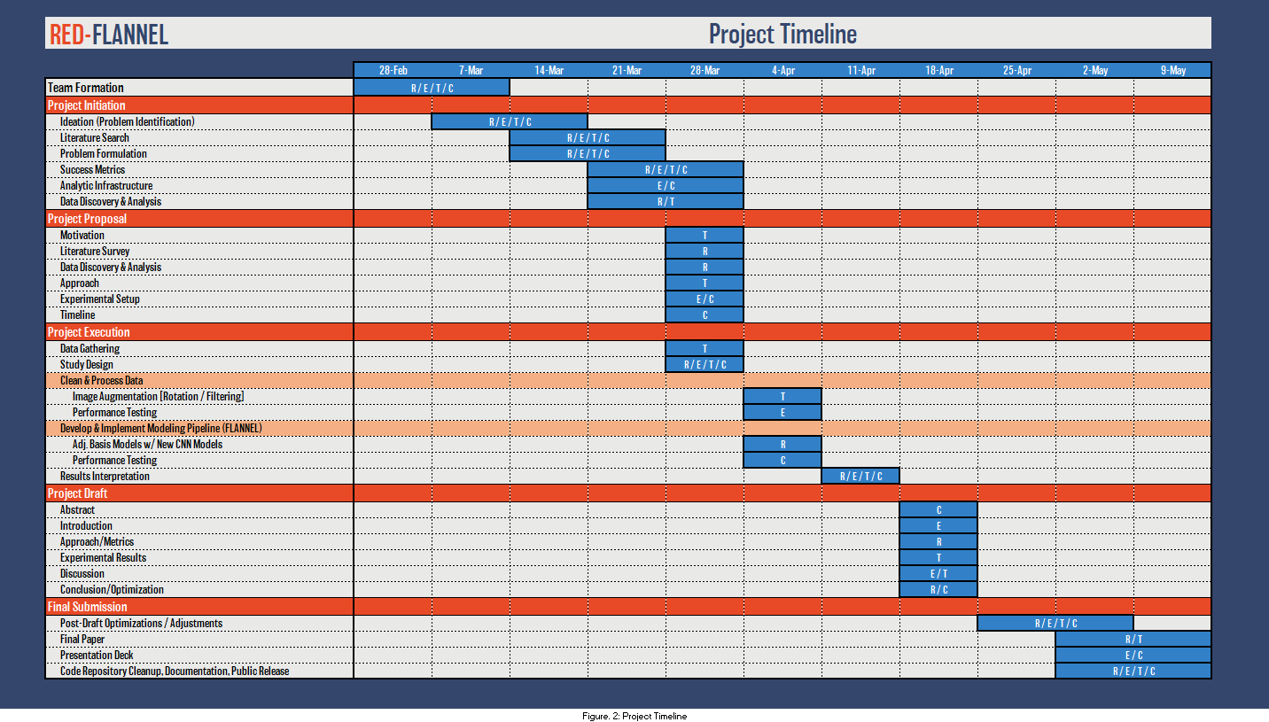
Figure. 2: Project Timeline

REFERENCES

- COVID-19 Dashboard by the Center for Systems Science and Engineering (CSSE) at Johns Hopkins University (JHU). https://coronavirus.jhu.edu/map.html. Access: 2021-03-29.
- Z. Qiao, A. Bae, L. Glass, C. Xiao, J. Sun. FLANNEL (Focal Loss bAsed Neural Network EnsembLe) for COVID-19 detection Journal of the American Medical Informatics Association, 28(3), 2021, 444–452.
- L.F. Rodrigues, M.C. Naldi, J.F. Mari. Comparing convolutional neural networks and preprocessing techniques for HEp-2 cell classification in immunofluorescence images. Computers in Biology and Medicine, 116, 2020.
- J. Wang, L. Perez. The Effectiveness of Data Augmentation in Image Classification using Deep Learning. arXiv:1712.04621, 2017.
- S. Jadon. COVID-19 detection from scarce chest x-ray image data using few-shot deep learning approach. Medical

Imaging 2021: Imaging Informatics for Healthcare, Research, and Applications, Proceedings Vol. 116010, 2021.
- L. Wang, Z.Q. Lin, & A.Wong. COVID-Net: a tailored deep convolutional neural network design for detection of COVID-19 cases from chest X-ray images. Scientific Reports, 10, 2020.
- X. Bai, R. Wang, Z. Xiong, et al. Artificial intelligence augmentation of radiologist performance in distinguishing COVID-19 from pneumonia of other origin at chest CT. Radiology, 296, 2020.
- S. Minaee, R. Kafieh, M. Sonka, S. Yazdani, G.J. Soufi. Deep-COVID: Predicting COVID-19 from chest X-ray images using deep transfer learning, Medical Image Analysis, Volume 65, 2020.
- T.D. Pham. Classification of COVID-19 chest X-rays with deep learning: new models or fine tuning? Health Information Science and Systems, 9, 2021.

